GDPR Testing User Guide

Grainger PLC
GDPR AnonymiSation

Version 1.0
July 08, 2024

Contents
1. Intended Audience 2
1.1 Identifying records for Anonymisation 2
1.1.1 Leads 3
1.1.2 Contacts / Person accounts 3
1.2 How Anonymisation works 4
1.2.1 Lead field changes 4
1.2.2 Contact field changes 5
1.2.3 Person Account field changes 6
1.3 ERROR EMAILS 8

Intended Audience
The document is intended for the following:

o Project Managers
o Testing end users
o Internal Salesforce administrators
o Quality Assurance testers

1.1 Identifying records for Anonymisation

1.1.1 Leads
- A Lead has a created date more than 1 year ago
- Lead is not converted
- Lead has not opted in after the communication email was sent
- Communication Opt-In Date is not 365 or more days prior to today

Then, the GDPR Anonymisation Date is set to Today + 1 day (for testing purposes only) as it is needed for Opt-in Communication window

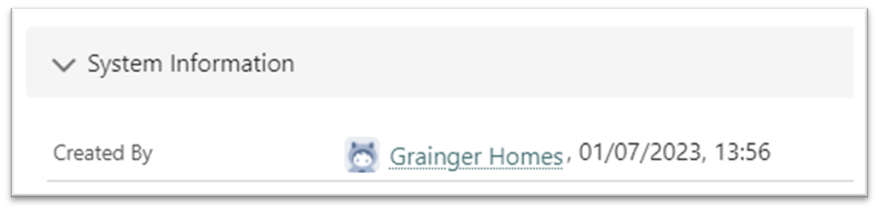

1.1.2 Contacts / Person accounts

- If the record is created more than 1 year ago AND

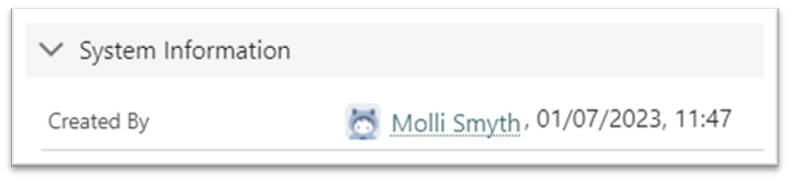

  - Does not have a contact role in a Closed Won opportunity (active, inactive) AND

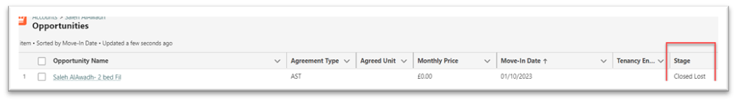

  - Does not have a contact role in an open opportunity created less than 365 days ago (active and inactive) AND

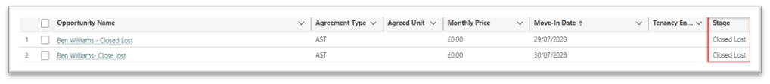

- Has NOT opted in after communication email was sent
  - Then GDPR Anonymisation Date should be set to Today + 1 day (for testing purposes only) as it is needed for Opt-in Communication window
  - If a Record has opted in (communication opt-in date) opt-in is valid for another year from opt-in date: PII data will not be anonymised, values remain intact

1.2 How Anonymisation works
- The ‘GDPR Anonymisation Date’ field will get date stamped with (today’s date + Opt in period)

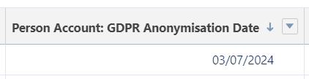

- Marketing cloud implementation will send out the opt-in email

- Data will be anonymised with anonymised values if not opted in as per the tables below

1.2.1 Lead field changes

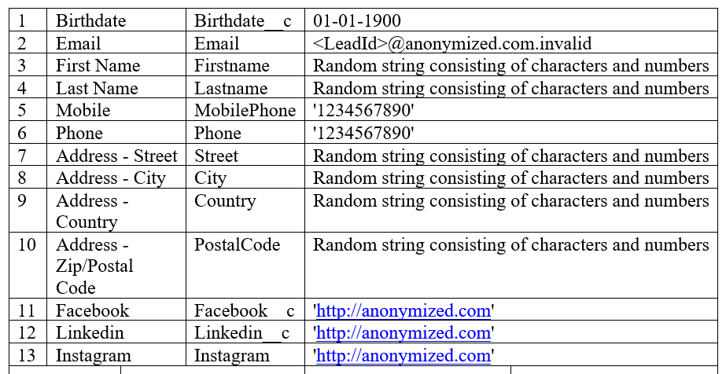

1.2.2 Contact field changes
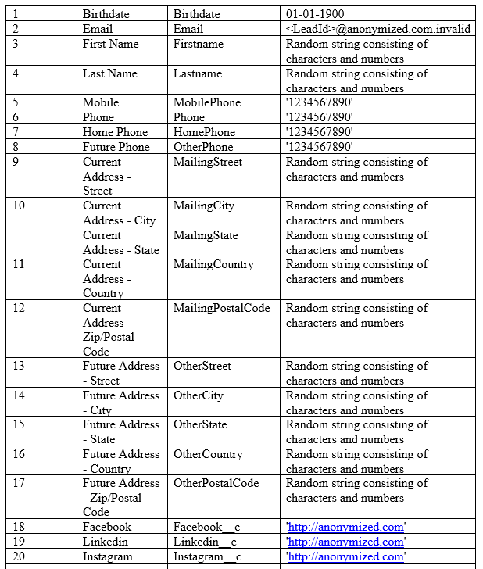

1.2.3 Person Account field changes
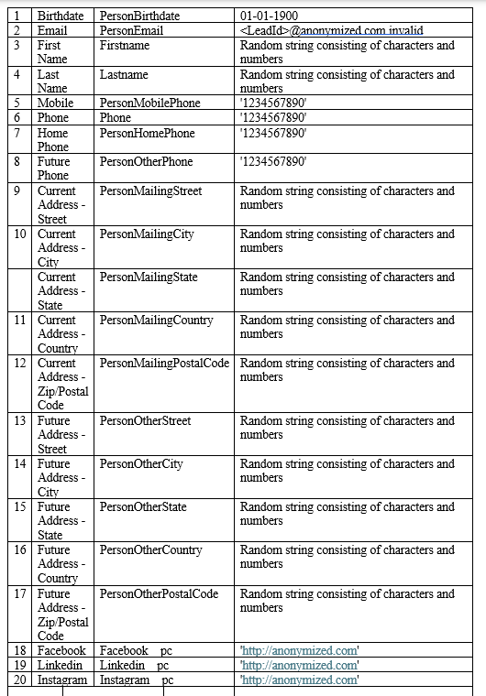

*Names will be assigned random unique text strings to avoid duplicate values

- GDPR Anonymised (checkbox) will be set to ‘TRUE’ to indicate record has been anonymised

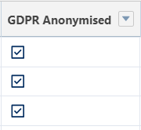

- Deletion of record Field Audit History for PII fields

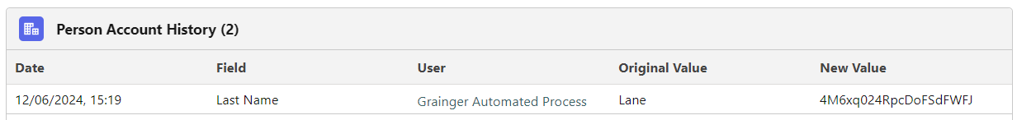

Note: The Salesforce admin can update the configuration as described below so that only one PII field on Lead/Contact/Person Account is anonymised on a given day. Towards the end of the UAT testing round, data can be restored and with updated configuration, all fields can be anonymised in one go as a trial run to match the production setup.

1.3 ERROR EMAILS
An email will be sent out in the case that there are errors running the GDPR Anonymisation batch process

